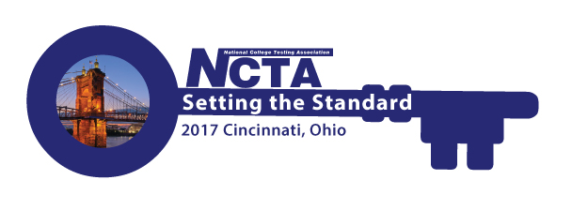
NCTA 2017 Annual Conference Committee Meeting
Monday, April 17, 2017
2:00 PM Eastern Time
GoToMeeting
https://global.gotomeeting.com/join/554423357

You can also dial in using your phone.
United States: +1 (646) 749-3112

Access Code: 554-423-357

Agenda

Roll Call - Jody Atkins

Committee Updates – Cindy James (chair)

Program – Bob Lang/Jim Wollack

Conference Agenda Update

Keynote Speaker Contract

Travel Scholarships

Virtual Conference – David Espinoza/Tremaine Williams

Sponsorship/Exhibits – Rosemary Freer

Resource Fair – Jamila Maxie

Host Committee – Paula Doughman

Conference App – Amystique Church

Conference Planner Update – Jody Atkins

Website Content

Conference Budget – Cindy/Jim

- Other/New Business

- Adjourn – Next meeting is May 15th

